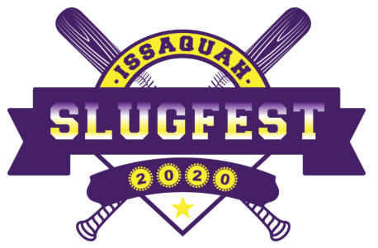

ISSAQUAH BASEBALL CLUB PRESENTS:
ISSAQUAH SLUGFEST 2023 WAIVER OF LIABILITY

Team Name: ____________________________ Home Phone: __________________
Manager: _____________________________ Cell: ______________________
Address: ________________________________ Email: ______________________
City: ______________________________________ State: _____ Zip: ____________
PLEASE READ BEFORE SIGNING: In consideration of participating in any way within the Slugfest 2023 tournament (a program run by the Issaquah Baseball Club), related events and activities, the undersigned acknowledges, appreciates, and agrees that:
1. The risk of injury from the activities involved in the program is significant, including the potential for permanent paralysis and death, and while particular rules, equipment, and personal discipline may reduce this risk, the risk of serious injury does exist; and,
2. I KNOWINGLY AND FREELY ASSUME ALL SUCH RISKS, both known and unknown, EVEN IF ARISING FROM THE NEGLIGENCE OF THE RELEASEES or others, and assume full responsibility for my participation; and,
3. I willingly agree to comply with the stated and customary terms and conditions for participation. If however I observe any unusual significant hazard during my presence or participation, I will remove myself from participation and bring such to the attention of the nearest official immediately; and,
4. I, for myself and on behalf of my heirs, assigns, personal representatives and next of kin, HEREBY RELEASE AND HOLD HARMLESS Issaquah Baseball Club, their officers, officials, agents and/or employees, other participants, sponsoring agencies, sponsors, advertisers, and, if applicable, owners and lessors of premises used to conduct the event Releases WITH RESPECT TO ANY AND ALL INJURY, DISABILITY, DEATH, or loss or damage to person or property, WHETHER ARISING FROM THE NEGLIGENCE OF THE RELEASEES OR OTHERWISE

I HAVE READ THIS RELEASE OF LIABILITY AND ASSUMPTION OF RISK AGREEMENT, FULLY UNDERSTAND ITS TERMS, UNDERSTAND THAT I HAVE GIVEN UP SUBSTANTIAL RIGHTS BY SIGNING IT, AND SIGN IT FREELY AND VOLUNTARILY WITHOUT ANY INDUCEMENT.
PARENT/GUARDIAN SIGNATURE SHOULD BE ON THE SAME NUMBERED LINE AS PLAYER S NAME APPEARS ON THIS ROSTER. By signing this roster, parent or legal guardian agrees to the above statements and verifies that the date of birth is correct. Parent or legal guardian of each youth player "MUST" sign below. FOR PARTICIPANTS OF MINORITY AGE: This is to certify that I, as parent/legal guardian with legal responsibility for this participant, do consent and agree to his/her release as provided above all of the Releases, and, for myself, my heirs, assigns, and next of kin, I release and agree to indemnify the Releases from any and all liabilities incident to my minor child s involvement or participation in these programs as provided above, EVEN IF ARISING FROM THEIR NEGLIGENCE.

ISSAQUAH BASEBALL CLUB PRESENTS:
ISSAQUAH SLUGFEST 2023 OFFICIAL ROSTER

# | Type or Print Name | DOB | Player Signature | Parent/Guardian Signature | Relationship
1
2
3
4
5
6
7
8
9
10
11
12
13
14

TEAM MANAGER AFFIDAVIT: I, the manager of the above-named team, do hereby state that all of the information supplied above is correct to the best of my knowledge and that all parent/guardian signatures listed above are true and correct. I further agree that each above listed player is eligible to compete with my team within this Slugfest 2023 Tournament.
MANAGER’S SIGNATURE: __________________________________________________
DATE: ___________________________

